SESSION 12 ASSIGNMENT 2

**Problem**: Given a list of strings - List[String] (“alpha”, “gamma”, “omega”, “zeta”, “beta”)

* find count of all strings with length 4
* convert the list of string to a list of integers, where each string is mapped to its corresponding length
* find count of all strings which contain alphabet ‘m’
* find the count of all strings which start with the alphabet ‘a’

**Code**:

import scala.collection.mutable.ListBuffer

class session_12_2 {

var container = List("alpha","gamma","omega","zeta","beta");

var i=0;

*//This command iterates through list displays string with length of 4*

def first():Unit={

println("String with length 4 :")

for (i <- 0 to (container.length-1)) {

if (container(i).length == 4)

println(container(i))

}

}

*//This command creates a new temp list of the elements corresponding to length of the string*

*//and then assign it to the same list “container”*

def second():Unit={

var temp = new ListBuffer[String]()

for (i <- 0 to (container.length-1)){

temp += container(i).length.toString

}

container = temp.toList

println("new List is "+ container)

container = List("alpha","gamma","omega","zeta","beta");

}

*//Finding the count of strings which have “m” character*

def third():Unit={

println("count of strings with \"m\" is " + container.count(s => s.indexOf("m")!= -1))

}

*//Finding the count of strings which has “a” character at beginning*

def fourth():Unit={

println("count of strings with \"m\" is " + container.count(s => s.indexOf("a")== 0))

}

}

object exec extends App{

var define = new session_12_2

println("The List on which we will be working : " + define.container.mkString(" , ") )

var first = define.first()

var second = define.second()

var third = define.third()

var fourth = define.fourth()

}

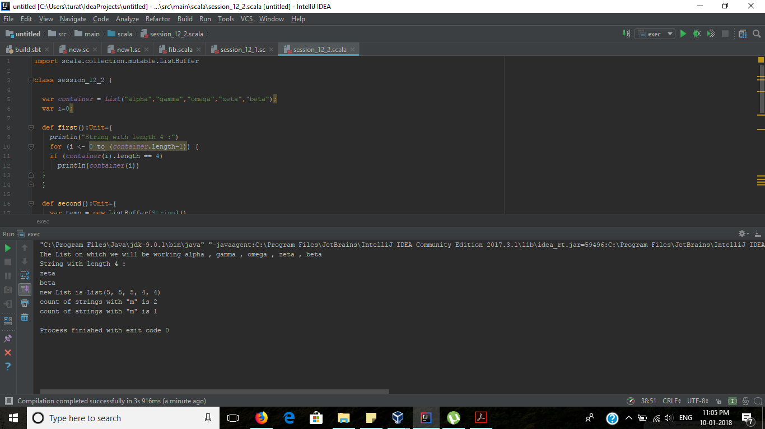

**Output**:

The List on which we will be working : alpha , gamma , omega , zeta , beta

String with length 4 :

zeta

beta

new List is List(5, 5, 5, 4, 4)

count of strings with "m" is 2

count of strings with "m" is 1

Process finished with exit code 0